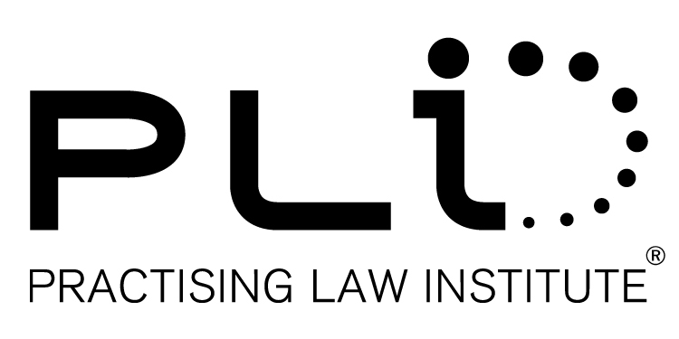
LCLD Annual Meeting – LEAD
September 19, 2013
Washington, D.C.

CLE Request Form

To request CLE credit, you must:
- Complete this form and submit it at the end of the conference; and
- Sign in and out at the CLE Desk when arriving at the program and departing for the day.

Please note:
- This form must be submitted with the appropriate signatures if you would like to receive CLE credit for attending the LCLD Annual Meeting.
- CLE credit is being sought by the Practising Law Institute (PLI) on behalf of LCLD for this program.
- PLI cannot guarantee approval in any jurisdiction. If you request credit in a jurisdiction where the program was not approved, you will be notified via email. If credit is granted in your jurisdiction, you will receive your certificate via email.
- For the credit type and amount applied for in each jurisdiction, please see the CLE Credit Information by State sheets at the CLE desk.

If you have any additional CLE questions, please contact PLI at cleadministrator@pli.edu.

Name:
Organization:
Address:
City: State: Zip:
Phone: Email:

To request CLE credit, please indicate your state(s) and license number(s) below:
State(s) State License #(s):

